Press Release 24th June 2025

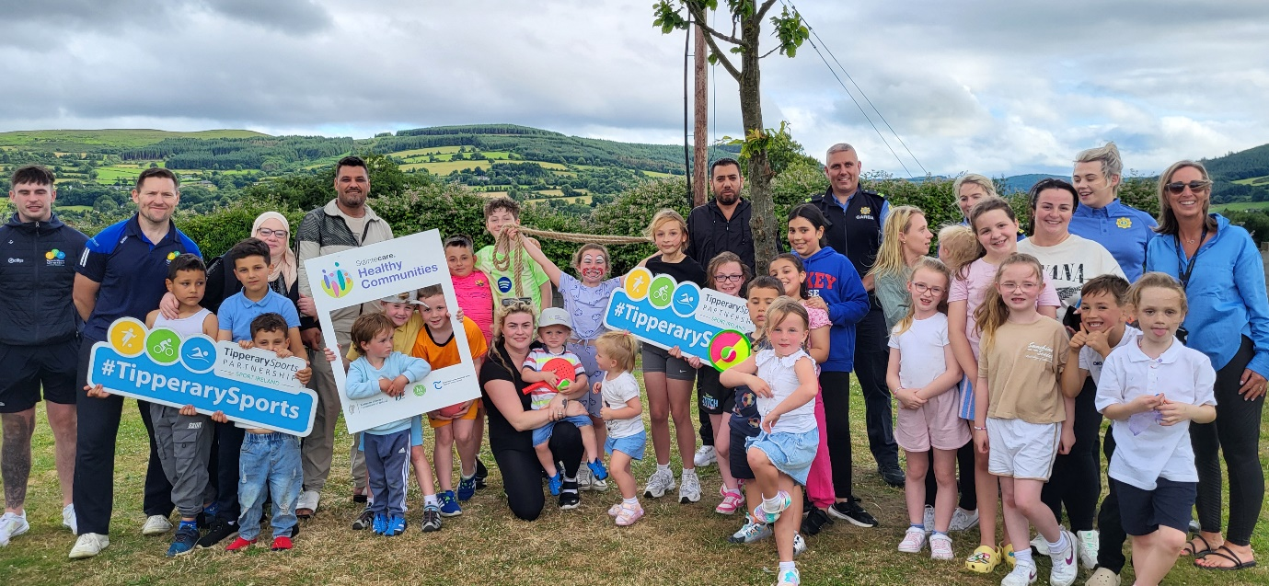

Playful Streets Brings Joy and Community Spirit to Glenconnor Hill Estate, Clonmel

On Tuesday, 24th June, Glenconnor Hill Estate in Clonmel came alive with colour, laughter, and creativity as local families gathered for a Playful Streets event — a joyful celebration of outdoor play, community connection, and healthy living.

Organised in partnership with Tipperary Sports Partnership, the Tipperary County Council Housing Community Liaison Officer, Sláintecare Healthy Communities and Healthy Tipperary, the event transformed the street into a vibrant, car-free zone where children could safely play games, get active, and enjoy their neighbourhood.

From hopscotch and hula hoops to giant games and obstacle courses, the event was packed with fun activities that brought smiles to faces of all ages. A special thanks goes to the children and parents of Glenconnor Hill, whose energy and enthusiasm made the day a true success.

A highlight of the afternoon was a surprise visit from Clonmel Gardaí, who took time to join in the fun and play alongside the children.

“This is what community is all about,” said Rob Murphy from Tipperary Sports Partnership. “Playful Streets not only encourages physical activity and outdoor fun but also helps foster relationships and pride in our local estates.”

The event supports Sláintecare’s vision for healthier, more connected communities by promoting safe, inclusive spaces for physical activity and wellbeing right where people live.

Organisers extended their heartfelt appreciation to all who participated and helped make the day memorable. The success of Playful Streets in Glenconnor Hill is a strong reminder of the impact local collaboration can have in building vibrant, healthy neighbourhoods.

