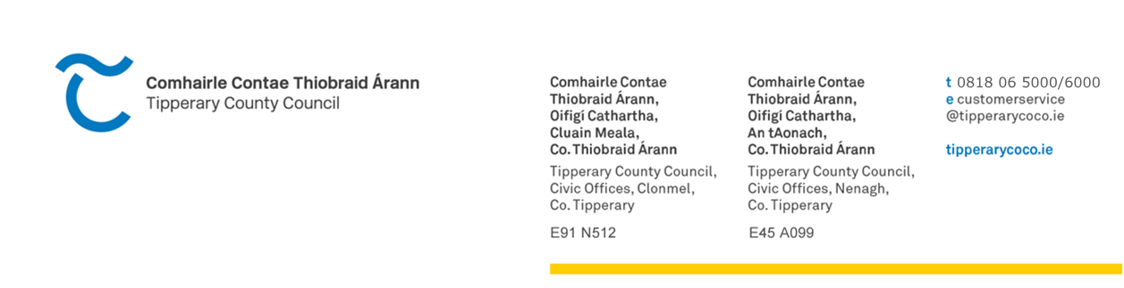

NENAGH MUNICIPAL DISTRICT

19th June 2026

A Chara,

You are hereby requested to attend the June Meeting of Nenagh Municipal District in Nenagh MD Chamber, Civic Offices, Nenagh on Thursday 25th June 2026 at 12.30 a.m. (following the Annual Meeting).

Please note that attendance is in person only – zoom facility is not currently available.

Is mise le meas,

Rosemary Joyce
______________

Rosemary Joyce

Meetings Administrator

AGENDA

- To note any Disclosures/Conflicts of Interest.
- To consider and adopt Minutes of May Meeting held on 21st May 2026.
- To receive update from Library Services, Culture and Biodiversity.
- To receive update from Economic, Community, Social Inclusion and Rural Development.
- To agree date for Drainage Committee meetings.
- To update members on projects & events.
- To update members on the Works Programme.

- To consider Notices of Motion:
Notice of Motion No: 3161 submitted by Cllr. L. Morgan Walsh
That Nenagh Municipal District write to Iarnród Éireann and the National Transport Authority (NTA) seeking an urgent explanation and action plan regarding the continued lack of service improvements on the Ballybrophy–Limerick rail line, following the recent reporting in the Limerick Leader which highlighted that Irish Rail is unable to increase services due to a shortage of gatekeepers and fleet resources.

Further, that this District request a clear and time-bound commitment from both agencies on how and when these staffing and operational barriers will be resolved, given Irish Rail’s stated long-term ambition to deliver trains every two hours on this route.

Notice of Motion No: 3159 submitted by Cllr. S. Morris
That Tipperary County Council carries out a safety review of the junction at AIBP/ Borrisokane Road/Puckane Road junction. There have been several accidents at this junction and with more and more vehicles now parking outside AIPB the sightlines are very poor and highly dangerous.

- To note Delegated Employee Orders for the Nenagh Municipal District.
- To consider items of Correspondence.
- Votes of Sympathy/Congratulations.
- Any other business.​

